Name: ________________________
Registration: ___________________

Design and implement the following traffic light controller in Verilog. (Simulation: 50% pts., FGPA Implementation: 50% pts.)

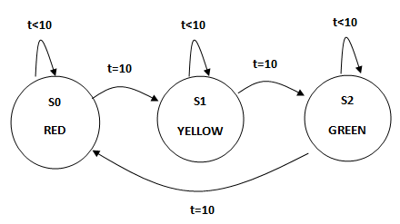

module traffic_lights2 (clk, light);

input clk;
output [2:0] light; reg [2:0] light;

parameter S0 = 0, S1 = 1, S2 = 2;
parameter RED = 3'b100, GREEN = 3'b010, YELLOW = 3'b001;

reg [0:1] state;

always @(posedge clk)
case (state)
S0: state <= S1;
S1: state <= S2;
S2: state <= S0;
default: state <= S0;
endcase

always @(state)
case (state)
S0: light = RED;
S1: light = YELLOW;
S2: light = GREEN;
default: light = RED;
endcase

endmodule

`timescale 1s/1s
module tst_traffic_lights2;

reg clk;
wire [2:0] light;

traffic_lights2 tf (clk, light);

initial
clk = 0;

always
#5 clk = ~clk;

endmodule

